SUBMITTED TO MR. ADNAN JELANI

APPLICATION OF ICT
Draw.io Lab Report #6
SUBMITTED BY MUHAMMAD IBRAHIM SIDDIQUI

Task 1:
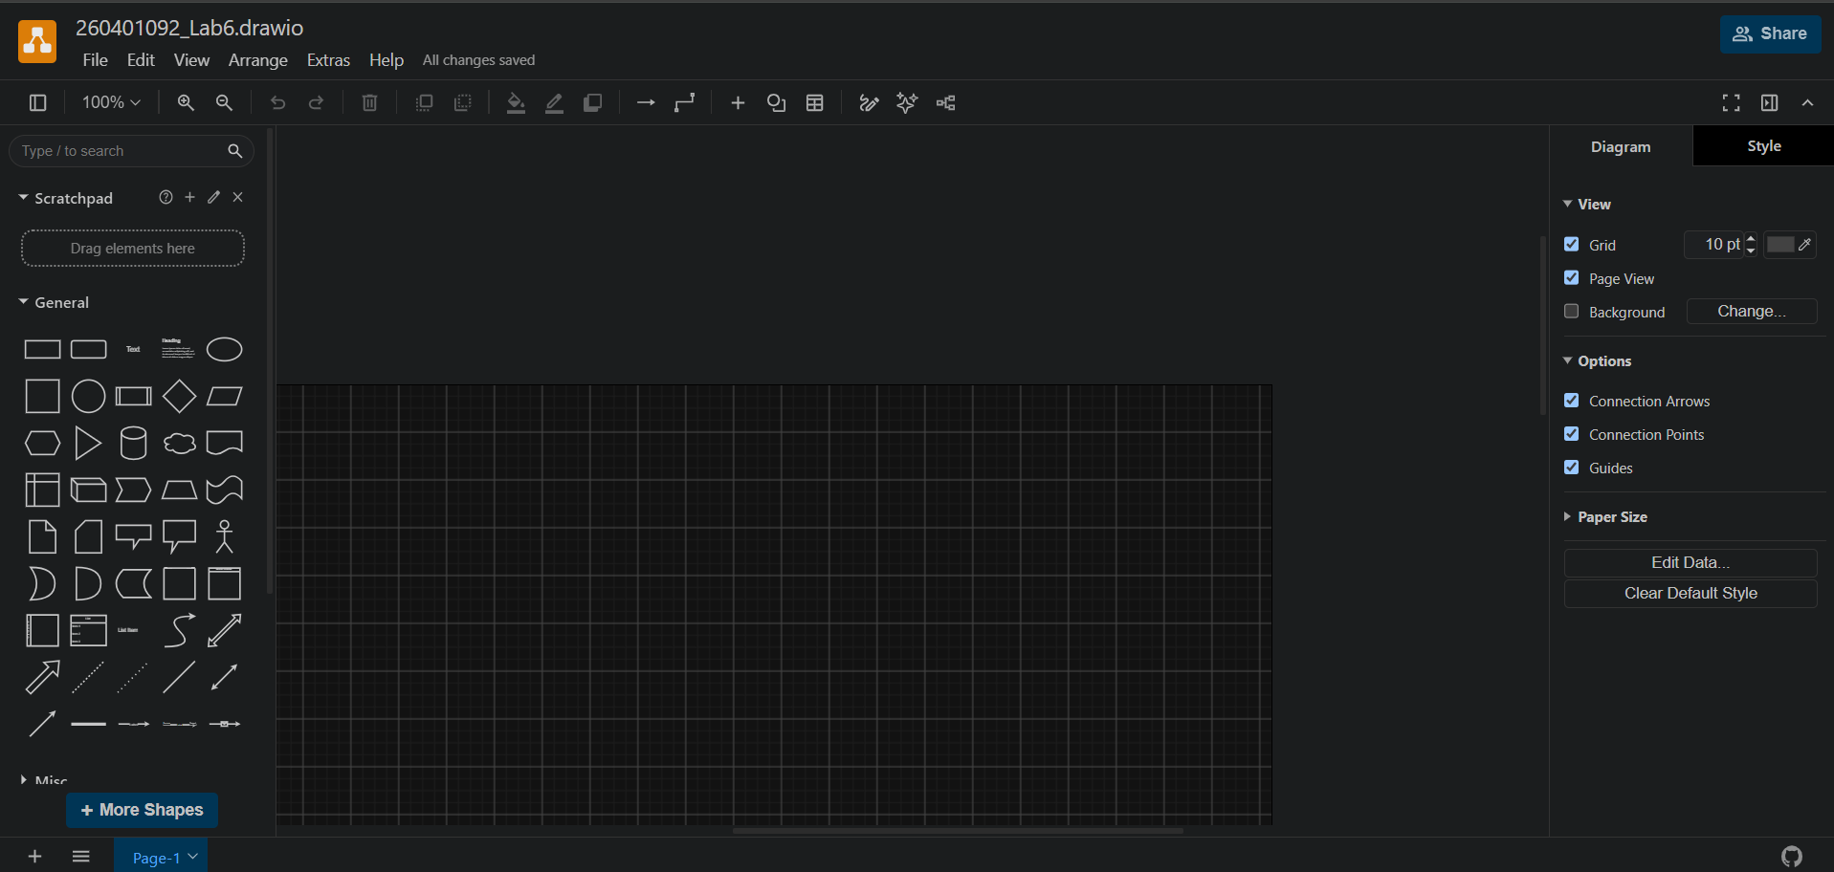

Task 2:
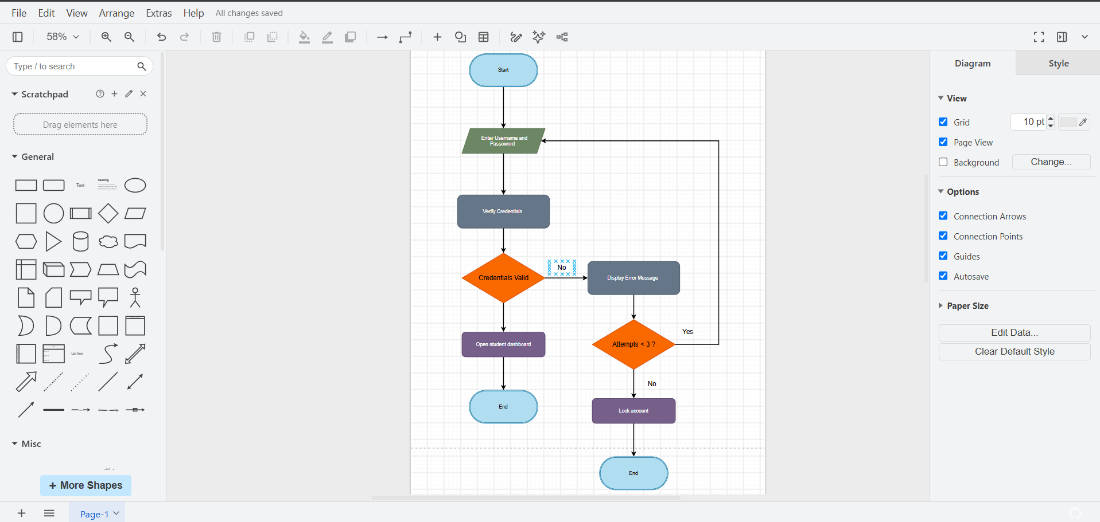

Task 3:
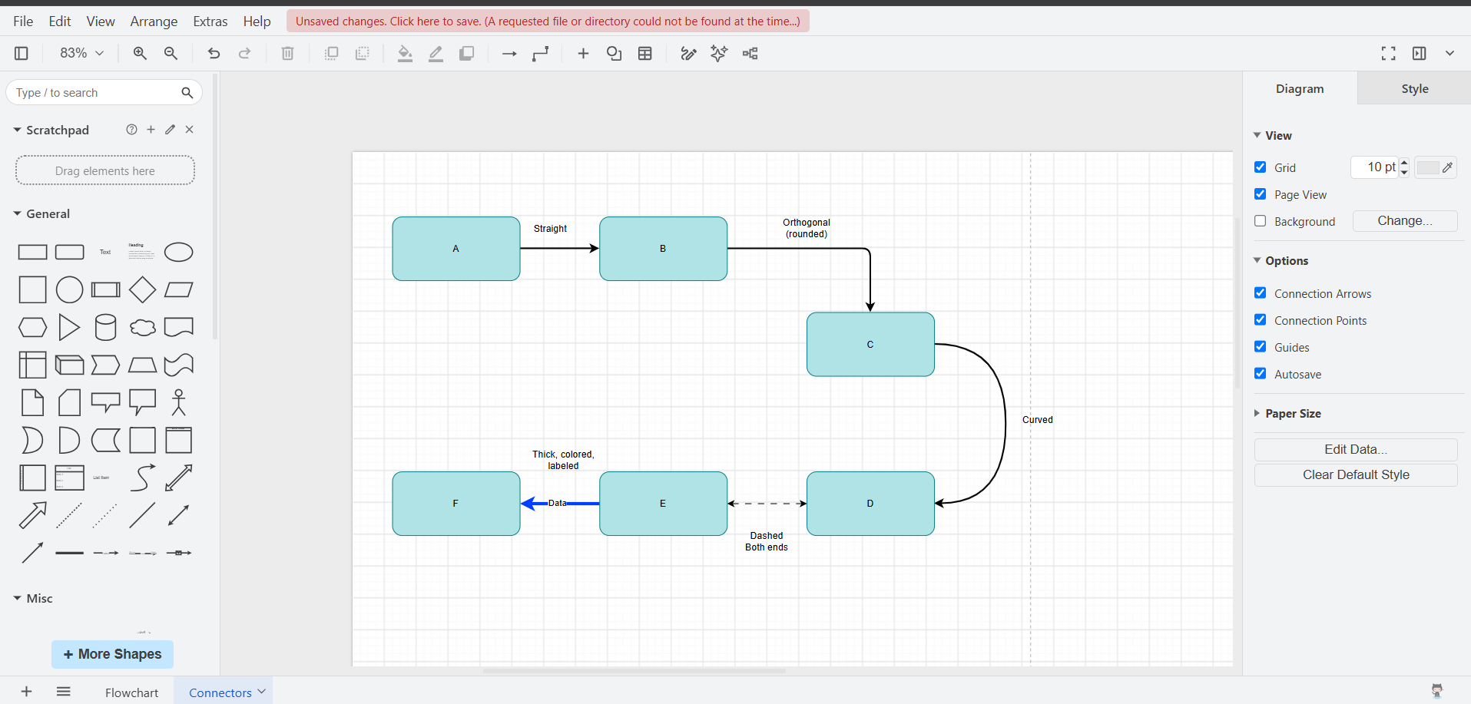

Task 4:

